
Ph: 2340810
OFFICE OF THE VILLAGE PANCHAYAT
VOLVOI
PONDA - GOA

Ref.No. VP/VOL/NIT/2020-21/258 Date: 02 /12/2020

NOTICE INVITING TENDER
The Dy.Sarpanch, Village Panchayat Volvoi Ponda invites sealed percentage rate tenders from approved and eligible contractors registered in appropriate class and category of PWD/WRD for execution of below mention works.
Sr.No. | Name of the Work | Estimated amount put to tender (excluding GST) | EMD Rs. | Time period | Class & category of Contractor |  | Cost of tender form
 |  |  |  |  | As per old registration | As per New Registration | Cost of tender form
1. | Construction of Garbage Shed at Metwada in W.No. 05 in V.P.Volvoi Ponda Taluka. | Rs.3,19,391.54/- | Rs.  7985/- | 60  Days | Class IV & Above Bldgs | Class V & Above Bldgs | Rs.1200/-
2. | Improvement of Shigmomand near Lumo Tari house at W.No. 04, Volvoi. | Rs.3,53,563.20/- | Rs.  8839/- | 60  Days | Class IV & Above Bldgs | Class V & Above RBLD | Rs.1200/-
3. | Repair of waiting room of Crematorium in W.No 1. Phonchebhat in Village Panchayat Volvoi. | Rs.1,66,244.64/- | Rs.  4156/- | 60  Days | Class IV & Above Bldgs | Class V & Above RBLD | Rs.1200/-
4. | Improvement to existing pathway near the house of Vinayak Naik at Innambhat Volvoi W.No 2. | Rs.1,22,316.20/- | Rs.  3058/- | 60  Days | Class V & Above RBLD/ Bldgs | Class V & Above RBLD/ Bldgs | Rs.1200/-

Terms and conditions:
- Last date of receiving application 16/12/2020up to 04:00 pm along with cost of tender form (Cash/DD/DCR) (Non- Refundable).
- Date of issue of blank tender form 22/12/2020 up to 04: 00 pm.
- Date of receipt of sealed tender 29/12/2020 up to 3.00 pm and will be opened on same day at 3.30 pm. in the Office of V.P Volvoi
- Application for issue of tender form shall be accompanied with
- Attested copy of valid registration certificate of the contractor in the concerned category of work.
- Attested copy of PAN card
- Copy of valid GST registration Certificate and acknowledgement of up to date filed returns with ARN (Application Reference Number generated on GST common portal.
- Declaration of the work in hand shall be submitted with detailed list indicating the present status on Rs 50/- Stamp paper( however tender form will not be issued to the person who has work in hand more than four times the tendering limit).
- EMD shall be in form of Demand draft/ Deposit Call Receipt (DCR)/Pay order from Nationalized or Scheduled bank drawn in favour of The Sarpanch, V.P Volvoi Payable at Volvoi.
- Contractor shall submit separate application for each work.
- Unsealed and conditional tenders will be rejected outright.
- The contractor shall quote the tender excluding GST & GST as applicable shall be paid separately on total value of work executed.
- For the tenders/ item of tender in case of being quoted abnormally below i.e. 20.00% below the estimated cost, than the contractor shall furnish on demand as additional performance security in the form of Bank guarantee from National / Schedule Bank for that amount which is worked out as difference between quoted amount and reasonable amount reduced by 20.00%
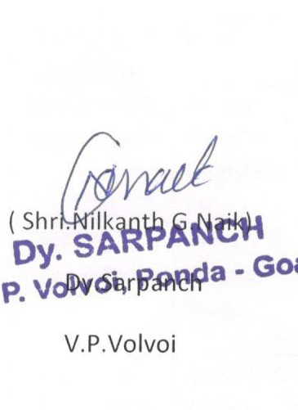
- Right to accept or reject any or all the tenders without assigning any reason is reserved.


Copy to,
- Village Panchayat Tivrem Orgao, Vere Vaghurme, Querim.
- The Block Development Officer, Ponda Goa,
- The Executive Engineer, Directorate of Panchayat, ADP-II, South, Margao-Goa
- The Executive Engineer, WDXVI (Buildings) Ponda Goa
- The Executive Engineer, WDXVIII (Roads) Ponda Goa
- The CEO,South Goa Zilla Panchayat, Old Collectorate Bldg., Margao-Goa
- The Editor , Daily _____________Goa , for publication
- Notice board

